**ACTION ITEMS STATUS REPORT**

|  |  |
| --- | --- |
| **Report Date** | **Project Name** |
| **January 2022** | **Automated In-Plant Line Inspection Reporting System** |

|  |  |  |  |  |
| --- | --- | --- | --- | --- |
| **Task, Actions Items, Milestones, Deliverables Overview** | | | | |
| **Task/Action Items / Milestones** | **Actions/ Solutions Performed** | **Status** | **Date Completed** | **% Complete** |
| * Learning the process of POSMD of how operation works | * DAI documentation (AIPLIRS) * Daily Receiving , Weekly Report, monthly report * Analyzing data gathered to be familiarized   *(see attached image below)* | On progress | 01/03/2022 - Present | 10 % |
| * Creating a page for the other function of AILPLIRS to be used | * Login page * POSMD, POSMS, RTD, MIO dashboard created   *( see attached image below )* | On progress | 01/03/2022 - Present | 5% |

|  |  |
| --- | --- |
| **Version and Patch History** | |
| **Versions** | **Patch Updates Release** |
| January Changes and Updates | January 2022 |
|  |  |

|  |
| --- |
| Additional Comments |
| * While waiting for the meeting and other concern. POSMD provides some documents including to their process in operation and for the last AIPLIRS documentation |
| Recommendations |
|  |

|  |  |
| --- | --- |
| **Prepared by:**  **BAYOG, JUFREY NIÑO E.**  **Noted by:**  **MARIANNE JANE REPASO** | **Reviewed by:**  **JANUARY M. NONES**  **Approved by:**  **Dr. EASTER F. OBLENA** |

**Login page**

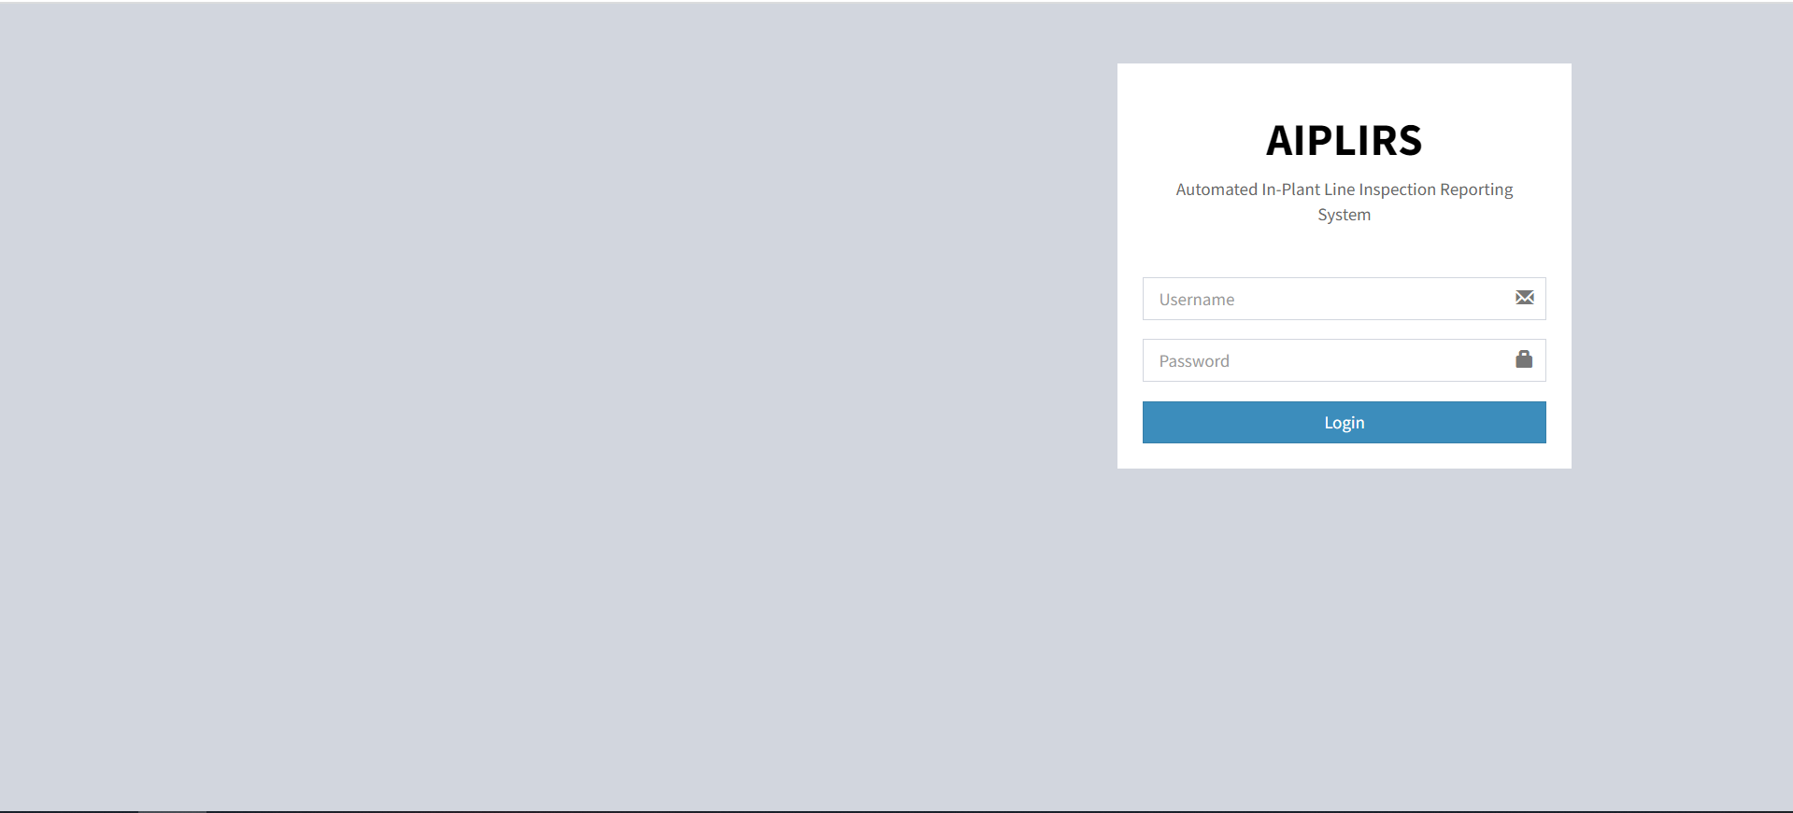

1. Designing on progress
2. Login is working, user will be redirected to the dashboard base to the role of their account

**Dashboard page (Meat Inspection Officer)**